CONDITIONAL SENTENCES
Always remember | If clause | Result clause | Examples
True in the present/Future  (General Truth) | Simple Present | Simple Present/Simple Future | - If she has enough time, she goes to the library once every week.  - If she has enough time, she will go to the library once every week.
Untrue in the present/future  (Unlikely to happen) | Simple Past | Would+ Simple Form | - If she had enough time, she would go to the library once every week. (However, the truth is that she does not have enough time, so she will not go to the library)
Untrue in the past  (Impossible situation in past) | Past Perfect | Would have+ past participle | - If she had had enough time, she would have gone to the library once every week. (However, the truth is that she didn´t have enough time, so she didn´t go anywhere.)

FIRST CONDITIONAL (TRUE IN THE PRESENT OR FUTURE)

- If I don’t eat breakfast, I always get hungry during class.
- Water freezes (will freeze) if the temperature goes below 32° F/0°C.
- If I don’t eat breakfast tomorrow morning, I will get hungry during class.
- If the weather is nice tomorrow, we will go on a picnic.

In (e): The simple present is used in the result clause to express a habitual activity or situation.
In (f): Either the simple present or the simple future is used in the result clause to express an established, predictable fact.
In (g) and (h): The simple future is used in the result clause when the sentence concerns a particular activity or situation in the future.

EXERCISE 1: Connect the phrases to make sentences.

1. If you hide behind the tree,
2. If you don’t hurry,
3. If you read more books,
4. If she doesn’t eat,
5. If they don’t do their homework,
a) you’ll know more words.
b) he’ll see you.
c) we’ll be late.
d) their teacher will be angry.
e) she’ll be hungry.

EXERCISE 2: Complete the conditional sentences.

1) If you _________________________ (not/behave), you __________________________ (get) a bad mark.

2) If she __________________________ (wear) a raincoat, she _________________________ (not/get) wet.

3) I ___________________________ (not /talk) to you if you ________________________ (not/ keep) my secret.

4) If he ___________________________ (leave) now, I __________________________ (never/ talk) to him again.

5) If your students _____________________ (work) hard, their results ___________________ (be) a lot better.

6) If you ____________________________ (wait) a minute, she ________________________ (be) here with Jack.

SECOND CONDITIONAL (UNTRUE (CONTRARY TO FACT) IN THE PRESENT/FUTURE)
- If I taught this class, I wouldn’t give tests. In (i): In truth, I don’t teach this class.
- If he were here right now, he would help us. In (j): In truth, he is not here right now.
- If I were you, I would accept their invitation. In (k): In truth, I am not you.

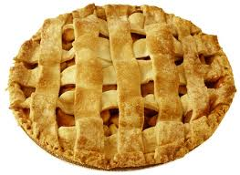
Note: Were is used for both singular and plural subjects. Was (with I, he, she, it) is sometimes used in very information speech but is not generally consider grammatically acceptable.

EXERCISE 3: Complete the sentences with the verbs in parentheses.
1. If I have enough apples, I (bake) _____will bake______ an apple pie this afternoon.
2. If I had enough apples, I (bake) _______________________ an apple pie this afternoon.
3. I will fix your bicycle if (have) _______________________ a screwdriver of the proper size.
4. I would fix your bicycle if I (have) _______________________ a screwdriver of the proper size.
5. I (make) ___________________ a tomato salad for the picnic tomorrow if the tomatoes in my garden are ripe.
6. I (make) ___________________ a tomato salad for the picnic tomorrow if the tomatoes in my garden are ripe.
7. Jack would shave today if he (have) _______________________ a sharp razor.
8. Jack will shave today if he (have) _______________________ a sharp razor.
9. Sally always answers the phone if she (be) _______________________ in her office.
10. Sally would answer the phone if she (be) _______________________ in her office right now.
11. I (not be) _________________ a student in this class if English (be) __________________ my native language.

EXERCISE 4: Write the correct form of the verbs in brackets.
- If I were you, I _____________________________________ (not wear) those old jeans.
- Terence _____________________________________ (win) the championship if he trained harder.
- If he _____________________________________ (be) taller, he could be a basketball player.
- If everybody _____________________________________ (protest), they would stop killing whales.
- The countryside _____________________________________ (be) more beautiful if people didn’t set fire to the forests every year.
- If you __________________________ (stop) smoking, you _______________________ (feel) much better.
- If the temperature ____________________ (drop) a bit more, it ______________________ (snow), but I don’t think it will.
- I _____________________ (read) the book if it ____________________ (be) interesting, but it’s so boring.
- If my boyfriend __________________ (treat) me like that, I ____________________ (break up) with him.

EXERCISE 5: Rewrite the sentences using the second conditional.

- I don’t have his phone number. I can´t call him. If I ________________________________________________________________________________________
- I feel terrible I can’t go to school. I ________________________________________________________________________________________
- My parents don’t like him because he looks so strange. If he ________________________________________________________________________________________
- He doesn’t get the good marks because he is lazy. He ________________________________________________________________________________________
- She doesn’t speak Portuguese because she doesn’t live in Portugal.
________________________________________________________________________________________
- You don’t lose weight because you eat too much.
________________________________________________________________________________________

THIRD CONDITIONAL (UNTRUE (CONTRARY TO FACT) IN THE PAST)
- If you had told me about the problem, I would have helped you.
- If they had studied, they would have passed the exam.
- If I hadn’t slipped on the ice, I wouldn’t have broken my arm.

In (m): In truth, they did not study. They failed the exam.

In (n): In truth, I slipped on the ice. I broke my arm.

Note: The auxiliary verbs are almost always contracted in speech. “If you’d told me, I would’ve helped you (OR: I’d’ve helped you).”

EXERCISE 6: Put the following words in order to create third conditional sentences
1) said / have / same / I'd / the / thing ……………………………………………………………
2) would / have / no. / He / said ……………………………………………………………
3) wouldn't / accepted. / They / have ……………………………………………………………
4) you / what / have / said? / would ……………………………………………………………
5) tried. / have / could / I ……………………………………………………………
6) it. / might / got / We / have ……………………………………………………………
7) You / have / done? / would / What ……………………………………………………………

EXERCISE 7: Complete the sentences with the verbs in parentheses.
If I (have) ___________________ enough money, I will go with you.
If I (have) ___________________ enough money, I would go with you.
If I (have) ___________________ enough money, I would have gone with you.
If the weather is nice tomorrow, we (go) ___________________ to the zoo.
If the weather were nice today, we (go) ___________________ to the zoo.
If the weather had been nice yesterday, we (go) ___________________ to the zoo.
If Sally (be) ___________________ at home tomorrow, I am going to visit her.
Jim isn’t home right now. If he (be) ___________________ at home right now, I (visit) __________________him.
Linda wasn’t at home yesterday. If she (be) ________________ at home yesterday, I (visit) ______________ her.

EXERCISE 8: Complete the sentences.
- If she _______________________ (arrive) on time, she wouldn’t have missed the English lesson.
- If you _____________________________ (be) more careful, you might not have broken your glasses.
- If he hadn´t watched TV until midnight, he ____________________________ (not be) late for work.
- You ______________________________ (not get) the job if you hadn´t applied for it.
- If I had invited you to my wedding party, ______________________________ (you/go)?
- She ____________________________ (have) better grades in her exams if she had worked harder.

EXERCISE 9: Rewrite the following sentences. Use the third conditional.
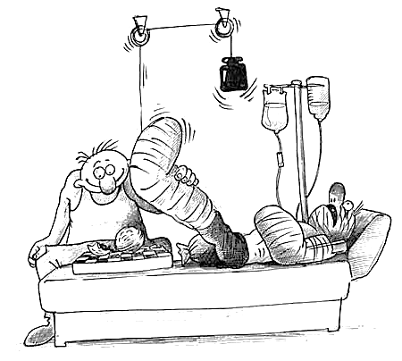
1. He didn´t get the job because he forgot to come to the interview.
2. I didn´t do any part-time jobs while I was at school, so I gained no work experience.
3. William broke into a house and went to prison.
4. It was more expensive because you didn´t come on the bus.
5. She didn´t get better because she refused to go to the doctor.
6. We didn´t pass because we didn´t study.
7. He didn´t go out with us because he broke his leg.
8. He broke his leg because he fell.

EXERCISE 10: Complete the sentences with the verbs in parentheses.
1. It’s too bad Helen isn’t here. If she (be) ________________ here, she (know) __________________ what to do.
2. Fred failed the test because he didn’t study. However, if he (study) ___________________ for the test, he (pass) ___________________ it.
3. An aerosol spray can will explode if you (throw) ___________________ it into a fire.
4. You should tell your father exactly what happened. If I (be) ___________________ you, I (tell) ___________________ him the truth as soon as possible.
5. If I (have) _________________ my camera with me yesterday, I (take) _________________ a picture of Alex standing on his head.
6. I’m almost ready to plant my garden. I have a lot of seeds. Maybe I have more than I need. If I (have) ___________________ more seeds than I need, I (give) ___________________ some to Nellie.
7. I got wet because I didn’t take my umbrella. However, I (get, not) ___________________ wet if I (remember) ___________________ to take my umbrella with me yesterday.
8. I (change) ___________________ the present economic policy if I (be) ___________________ the President of the United States.
9. If the teacher (be) ___________________ absent tomorrow, class will be cancelled.
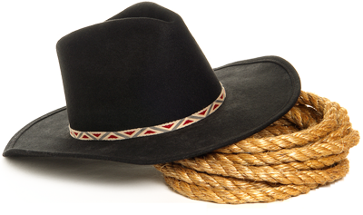
10. George has only two pairs of socks. If he (have) ___________________ more than two pairs of socks, he (have to, not) ___________________ wash his socks so often.
11. That sounds like a good job offer. If I (be) ___________________ you, I (accept) ___________________ it.
12. The cowboy pulled his gun to shoot at the rattlesnake, but he was too late. If he (be) ___________________ quicker to pull the trigger, the snake (bite, not) ___________________ him on the ankle. It’s a good thing he was wearing heavy leather boots.

EXERCISE 11: Choose the correct ending for the following sentences
1. If the weather had been better yesterday, ……………………………………………………………
2. If Jane had arrived on time last night, ……………………………………………………………
3. If I had studied more for my exams, ……………………………………………………………
4. We would have had a wonderful weekend ……………………………………………………………
5. The party would have been funnier ……………………………………………………………

EXERCISE 12: Supply the appropriate auxiliary verb
1. I don’t have a pen, but if I ___________________, I would lend it to you.
2. He is busy right now, but if he ___________________, he would help us.
3. I didn’t vote in the last election, but if I ___________________, I would have voted for Senator Anderson.
4. I don’t have enough money, but if I ___________________, I would buy that book.
5. The weather is cold today, but if it ___________________, I would go swimming.
6. She didn’t come, but if she ___________________, she would have met my brother.
7. I’m not a good cook, but if I ___________________, I would make all of my own meals.
8. I have to go to class this afternoon, but if I ___________________, I would go downtown with you.
9. He didn’t go to a doctor, but if he ___________________, the cut on his hand wouldn’t have gotten infected.
10. I always pay my bills. If I ___________________, I would get in a lot of trouble.
11. Helium is lighter than air. If it ___________________, a helium-filled balloon wouldn’t float upward.
12. I called my husband to tell him I would be late. If I ___________________, he would have gotten worried about me.
ORAL: WHAT WOULD YOU…? What would you do in these situations?
1) If you had to choose a place to live outside your country, which one would you choose and why?
2) Quit Facebook?
3) If you had plenty of money to give away, what would you do with it?
4) What three things would you take if your house was on fire?
8) You find a lot of money in the street?
9) You were a girl/boy for a day?
10) What will happen if we don’t protect the environment?
11) If you had a child, how would you bring him/her up?
13) If you were a teacher, how would you behave with your students?
14) What would happen if you failed three courses this year?
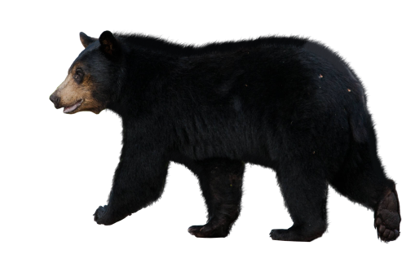
15) You could be invisible for a day?
16) You saw a bear in the forest?
17) Had one day left to live?
18) Were in a war?
19) You find out you were adopted?
20) Had superpowers?
21) You can get any job you wanted?
22) Your friend is drunk and cannot drive?

ORAL (BOOKS CLOSED): Answer each question. Begin with “No, but…”
Example: Do you have a dollar?
Response: No, but if I did (No, but if I had a dollar), I would lend it to you.

- Are you rich?
- Do you have a car?
- Are you a bird?
- Are you in (student’s country/hometown)?
- Do you live in an apartment? Dormitory? Hotel?
- Are you the teacher of this class?
- Do you have your own airplane?
- Are you (the President of the United States)?
- Are you tired?
- Are you at home right now?
- Are you married? Single?
- Do you speak (another language)?
- Is the weather hot/cold today?
- Are you hungry?
- Do you live in (New York City)?

EXERCISE 14: ORAL (BOOKS CLOSED): Begin your response with “But if I had known…”
Example: There was a test yesterday. You didn’t know that, so you didn’t study.
Response: But If I had known (that there was a test yesterday), I would have studied.
- Your friend was in the hospital. You didn’t know that, so you didn’t visit her.
- I’ve never met your friend. You didn’t know that, so you didn’t introduce me.
- There was a party last night. You didn’t know that, so you didn’t go.
- Your friend’s parents are in town. You didn’t know that, so you didn’t invite them to dinner.
- I wanted to go to the soccer game. You didn’t know that, so you didn’t buy another ticket.
- I was at home last night. You didn’t know that, so you didn’t visit me.
- Your sister wanted a gold necklace for her birthday. You didn’t know that, so you didn’t buy her one.
- I had a problem. You didn’t know that, so you didn’t offer to help.
- The book you loved was at a discount. You didn’t know that, so you didn’t buy it.
- The girl you liked had a boyfriend. You didn’t know that, so she turned you down.

EXERCISE 15: Change the following statements into conditional sentences.
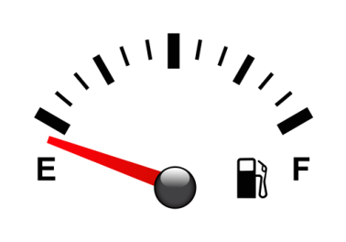
- I didn’t buy it because I didn’t have enough money. But… I would have bought it if I’d had enough money.
- I won’t buy it because I don’t have enough money. But…
- You got into so much trouble because you didn’t listen to me. But…
- We ran out of gas because we didn’t stop at the service station. But…
- Jack came, so I wasn’t disappointed. But…
- The woman didn’t die because she received immediate medical attention. But…
- There are so many bugs in the room because there isn’t a screen on the window. But…
- Ann didn’t pass the entrance examination, so she wasn’t admitted to the university. But…

15-1 USING PROGRESSIVE VERB FORMS
Notice the use of progressive verb forms in the following examples. Even in conditional sentences, progressive verb forms are used in progressive situations.
- TRUE: It is raining right now, so I will not go for a walk.
- CONDITIONAL: If it were not raining right now, I would go for a walk.
- TRUE: I am not living in Chile. I am not working at a bank.
- CONDITIONAL: If I were living in Chile, I would be working at a bank.
- TRUE: It was raining yesterday afternoon, so I did not go for a walk.
- CONDITIONAL: If it had not been raining, I would have gone for a walk.
- TRUE: I was not living in Chile last year. I was not working at a bank.
- CONDITIONAL: If I had been living in Chile last year, I would have been working at a bank.

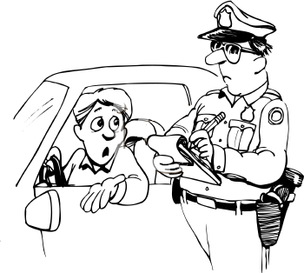
- EXERCISE 16: Change the following statements into conditional sentences.
1. It is snowing, so I won’t go with you. But… if it weren’t snowing, I would go with you.
2. This child is crying because his mother isn’t here. But…
3. You weren’t listening, so you didn’t understand the directions. But…
4. Joe got a ticket because he was driving too fast. But…
5. I was listening to the radio, so I heard the news bulleting. But…
6. Grandpa is not wearing his hearing aid because it’s broken. But…
7. You were sleeping, so I didn’t tell you the news as soon as I heard it. But…
8. I’m enjoying myself, so I won’t leave. But…

16-1 USING “MIXED TIME” IN CONDITIONAL SENTENCES

Frequently the time in the “if clause” and the time in the “result clause” are different: One clause may be in the present and the other in the past. Notice the past and present times are mixed in the sentences in the following examples.

- TRUE: I did not eat breakfast several hours ago, so I am hungry now.
- CONDITIONAL: If I had eaten breakfast several hours ago, I would not be hungry now.
(past) (present)

- TRUE: He is not a good student. He did not study for the test yesterday.
- CONDITIONAL: if he were a good student, he would have studied for the test.
(present) (past)

EXERCISE 17: Change the following statements into conditional sentences.
1. I’m hungry now because I didn’t eat dinner. But… if I’d eaten dinner, I wouldn’t be hungry now.
2. The room is full of flies because you let the door open. But…
3. You are tired this morning because you didn’t go to bed at a reasonable hour last night. But…
4. I didn’t finish my report yesterday, so I can’t begin a new project today. But…
5. Helen is sick because she didn’t follow the doctor’s orders. But…
6. I’m not you, so I didn’t tell him the truth. But…
7. I don’t know anything about plumbing, so I didn’t fix the leak in the sink myself. But…
8. I received a good job offer from the oil, so I won’t seriously consider taking the job with the electronics firm. But…

17-1 USING COULD, MIGHT, AND SHOULD

- If I were a bird, I could fly home.
- If I could sing as well as you, I would join the opera.
- If I’d had enough money, I could have gone to Florida for vacation.
In (a): could fly = would be able to fly
In (b): could sing = were able to sing
In (c): could have gone = would have been able to go

- If I don’t get a scholarship, I might get a job instead of going to graduate school next fall.
- If you were a better student, you might get better grades.
- If you had told me about your problem, I might have been able to help you.
In (d): I might get = maybe I will get
In (e): you might get = maybe you would get
In (f): I might have been = maybe I would have been

- If John should call, tell him I’ll be back around five.
- If there should be another world war, the continued existence of the human race would be in jeopardy.

In (g): If John should call indicates a little more uncertainty or doubt than If John calls, but the meaning of the two is basically the same.
In (h): If there should be indicates more uncertainty or doubt then If there were.

EXERCISE 18: Complete the following.
1. I could _________________ go to Arizona over vacation if I had enough time. __________________________
2. I could buy __________________________________________________________________________________
3. I would buy __________________________________________________________________________________
4. I could have bought ___________________________________________________________________________
5. I would have bought ___________________________________________________________________________
6. If I could speak _______________________________________________________________________________
7. You might have passed the test__________________________________________________________________
8. If you should need to get in touch with me later ____________________________________________________
9. If it should rain tomorrow ______________________________________________________________________
10. I could have finished my work on time. __________________________________________________________

18-1 OMITTING IF

- Were I you, I wouldn’t do that.
- Had I known, I would have told you.
- Should anyone call, please take a message.

With were, had (past perfect), and should, sometimes if is omitted and the subject and verb are inverted.
In (a): Were I you = If I were you
In (b): Had I known = If I had known
In (c): Should anyone call = If anyone should call
EXERCISE 19: Give sentences with the same meaning by omitting if from the conditional sentences.
1. The other team committed a foul, but the referee didn’t see it. If the referee had seen it, our team would have won the game. Had the referee seen it, our team would have won the game.
2. Your boss sounds like a real tyrant. If I were you, I would look for another job.
3. You really should learn how to use a computer. If you had used a computer, you could have finished the work in half the time.
4. I’ll be out of my office until 2:00. If you should need to reach me, I’ll be in the conference room.
5. The factory was on the verge of bankruptcy. If it had gone out of business, hundreds of people would have lost their livelihood.
6. We would have won the game if Thompson had caught the ball.
7. If Thompson had not dropped the ball, we would have won the game.*
8. The artists and creative thinkers throughout the history of the world have changed all of our lives. If they had not dared to be different, the history of civilization would have to be rewritten.
9. If there should be a global nuclear war, some scientists predict that life on earth as we know it would end forever.
10. If Tom had told the truth about his education background, he probably wouldn’t have gotten the job with the accounting firm. I suspect his boss will figure it out and fire him one of these days.
11. I know you’re getting discouraged and are planning to drop out of school. However, if you were to finish your education, many more career opportunities would be open to you.
12. I’m glad I went to the meeting. If I hadn’t been there, my proposal probably would not have been accepted.

*In the negative, not follows the subject. It is not contracted with the auxiliary verb:
CORRECT: Had I not seen it with my own eyes, I wouldn’t have believed it.
INCORRECT: Hadn’t I seen it with my own eyes,…

19-1 IMPLIED CONDITIONS
Often the “if clause” is implied, not stated. Conditional verbs are still used in the “result clause.”
- I would have gone with you, but I had to study. (Implied condition: … if I hadn’t had to study)
- I never would have succeeded without your help. (Implied condition: … if you hadn’t helped me)
Conditional verbs are frequently used following otherwise. In (c), the implied “if clause” is: If she had not run…
- She ran; otherwise, she would have missed her bus.

EXERCISE 20: Give sentences with the same meaning by using “if clauses.”
1. I would have visited you, but I didn’t know that you were at home.
I would have visited you if I had known you were at home.
2. It wouldn’t have been a good meeting without Rosa.
It wouldn’t have been a good meeting if Rosa hadn’t been there.
3. I would have answered the phone, but I didn’t hear it ring.
4. I couldn’t have finished the work without your help.
5. I would have been on time, but I left too late.
6. He would have taken a taxi, but she didn’t have enough money.
7. I like to travel. I would have gone to Nepal last summer, but I didn’t have enough money.
8. I stepped on the brakes. Otherwise, I would have hit the child on the bicycle.
9. Cathy turned down the volume on the tape player. Otherwise, the neighbors probably would have called to complain about the noise.
10. Jack would have finished his education, but he had to quit school and find a job in order to support his family.
EXERCISE 21: Complete the sentences with the verbs in parentheses. Some of the verbs are passive.
1. If I could speak Japanese, I (spend) _____________________ next year studying in Japan.
2. Had I known Mr. Jung was in the hospital, I (spend) _____________________ him a note and some flowers.
3. We will move into our new house next month if it (complete) _____________________ by then.
4. How old (be, you) _____________________ now if you (be) _____________________ born in the year 1900?
5. It’s too bad that it’s snowing. If it (snow, not) _____________________, we could go for a drive.
6. I was very tired. Otherwise, I (go) _____________________ to the party with you last night.
7. I’m broke, but I (have) _____________________ plenty of money now if I (spend, not) _____________________ so much yesterday.
8. That child had a narrow escape. She (hit) _____________________ by a car if her father (pull, not) _____________________ her out of the street.
9. I’m glad I have so many friends and such a wonderful family. Life without any friends or family (be) _____________________ lonely for me.
10. My grandfather is no longer alive, but if he (be) _____________________, I’m sure he (be) _____________________ proud of me.
11. If you (sleep, not) _____________________ last night when we arrived, I would have asked you to go with us, but I didn’t want to wake you up.
12. Bill has such a bad memory that he (forget) _____________________ his head if it (be, not) _____________________ attached to his body.
13. According to one report, the average hen lays 247 eggs a year, and the average person eats 255 eggs a year. If hens (outnumber, not) _____________________ people, the average person (eat, not) _____________________ 255 eggs a year.

EXERCISE 22: Complete the sentences with the verbs in parentheses. (*unless = if not)

1. A: What would you be doing right now if you (be, not) _____________________ in class?
B: I (sleep) _____________________.

2. A: Why were you late for the meeting?
B: Well, I (be) _____________________ there on time, but I had a flat tire on the way.

3. A: How did you get to work this morning?
B: I drove. I (take) _____________________ the bus, but I overslept.

4. A: Did you know that Bob got 100% on the test?
B: Really? That surprises me. If I didn’t know better, I (think) _____________________ he cheated.

5. A: Boy, is it ever hot today!
B: You said it! If there (be) _____________________ only a breeze, it (be, not) _____________________ quite so unbearable.

6. A: Why isn’t Peggy Adams in class today?
B: I don’t know, but I’m sure she (be, not) _____________________ absent unless* she (have) _____________________ a good reason.

7. A: When did Mark graduate?
B: He didn’t.
A: Oh?
B: He had to quit school because of some trouble at home. Otherwise, he (graduate) _____________________ last June.

8. A: Hi, sorry I’m late.
B: That’s okay.
A: I (be) _____________________ here sooner, but I had car trouble.

9. A: Want to ride on the roller coaster?
B: No way! I (ride, not) _____________________ on the roller coaster even if you paid me a million dollars.
10. A: hi, Pat. Come on in.
B: Oh, I didn’t know you had company. I (come, not) _____________________ (know, I) _____________________ someone was here.
A: That’s okay. Come on and let me introduce you to my friends.

11. A: How did you do on the test?
B: Not so well. I (do) _____________________ much better, but I misread the direction for the last section.

12. A: Do you really mean it?
B: Of course! I (say, not) _____________________ it unless I (mean) _____________________ it.

13. A: Are you coming to the party?
B: I don’t think so, but if I change my mind, I (tell) _____________________ you.

14. A: I hear Dorothy had an accident. Was it serious?
B: No. Luckily, she wasn’t driving fast at the time of the accident. If she (drive) faster, I’m sure it (be) _____________________ a more serious accident.

EXERCISE 23: Complete the following. Add commas where necessary.
1. If it hadn’t rained _____________________________________________________________________________
2. If it weren’t raining ____________________________________________________________________________
3. You would have passed the test had ______________________________________________________________
4. It’s a good thing we took a map with us. Otherwise _________________________________________________
5. Without electricity modern life __________________________________________________________________
6. If you hadn’t reminded me about the meeting tonight _______________________________________________
7. Should you need any help ______________________________________________________________________
8. If I could choose any profession I wanted _________________________________________________________
9. If I were at home right now _____________________________________________________________________
10. Without your help yesterday ___________________________________________________________________
11. Were I you _________________________________________________________________________________
12. What would you do if ________________________________________________________________________
13. If I had the chance to live my life over again ______________________________________________________
14. Had I known ________________________________________________________________________________
15. Can you imagine what life would be like if _______________________________________________________

EXERCISE 24 – ORAL (BOOKS CLOSED): Answer the questions.
Example: Suppose the student sitting next to you drops his/her pen. What would you do?
Response: I would pick it up for him/her.
1. Suppose (pretend) there is a fire in this building right now. What would you do?
2. Suppose there is a fire in your room or apartment or house. You have time to save only one thing. What would you save?
3. Suppose you go to the bank to cash a check for twenty dollars. The bank teller cashes your check and you leave, but when you count the money, you find she gave you thirty dollars instead of twenty. What would you do?
4. Same situation, but she gave you only fifteen dollars instead of twenty.
5. John was cheating during an examination. The teacher saw him. Suppose you were the teacher. What would you have done?
6. You go to a party. A man starts talking to you, but he is speaking so fast that you can’t catch what he is saying. What would you do?
7. Late at night you’re driving your car down a deserted street. You’re all alone. In an attempt to avoid a dog in the road, you swerve to one side and hit a parked car. You know that no one saw you. What would you do?
8. Mary goes to a friend’s house for dinner. Her friend serves a dish that Mary can’t stand, doesn’t like at all. What if you were Mary?
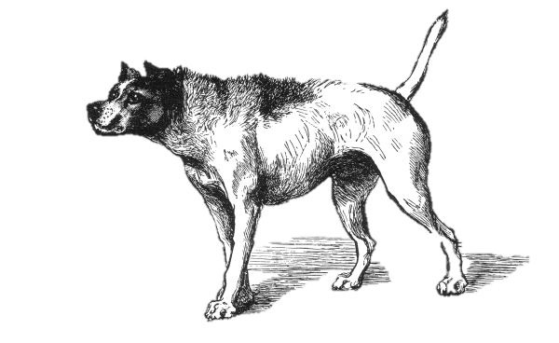
9. My friend John borrowed ten dollars from me and told me he would repay it in a couple of days, but it’s been three weeks. I think he has forgotten about it. I really need the money, but I don’t want to ask him for it. Give me some advice.
10. John was driving over the speed limit. A police car began to chase him, with red lights flashing. John stepped on the accelerator and tried to escape the police car. Put yourself in his position.
11. You are walking down the street and suddenly a large dog jumps in front of you. The dog doesn’t look friendly. He is growling and moving toward you. If that happened…
12. Suppose you are walking down the street at night all by yourself. A man suddenly appears in front of you. He has a gun. He says, “Give me your money.” Would you try to take his gun away?
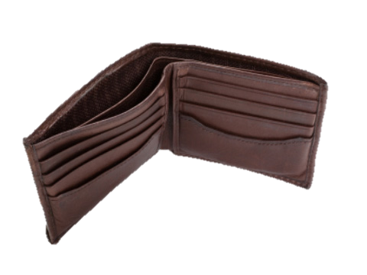
13. Suppose you go to (Chicago) to visit a friend. You have never been there before. Your friend said he would meet you at the airport, but he’s not there. You wait for a long time, but he never shows up. You try to call him, but nobody answers the phone. Now what?
14. You are just falling asleep when you hear a burglar opening your bedroom window and climbing in. What would you do?
15. You ask a very special person to go to dinner with you. You like this person very much and want to make a good impression. You go to a fancy restaurant and have a wonderful meal. But when you reach for your wallet, you discover that it is not there. You have no money with you.

EXERCISE 25-WRITTEN: Following are topics for writing.
1. If, beginning tomorrow, you had a two-week holiday and unlimited funds, what would you do? Why?
2. If you had to teach your language to a person who knew nothing about your language at all, how would you begin? What would you do so that this person could learn your language as quickly and easily as possible?
3. If you were Philosopher-King of the world, how would you govern? What would you do? What changes would you make? (A “Philosopher_King” may be defined as a person who has ideal wisdom and unlimited power to shape the world as s/he wishes.)
4. Suppose you had only one year to live. What would you do?
5. Describe your activities if you were in some other place. (in this country or in the world) at present. Describe your probable activities today, yesterday, and tomorrow. Include the activities of other people you would be with if you were in this place.

